***Word: 2913***

***Live Challenge: PCUP Company***

***Final Group project-Team 2***

***Maksat Mametjumayev, Marbella Tirado, James Clifford, Yosef Wossen***

***MKT 200-BOS1 | Professor: Katarzyna Bachnik |

***Table of Contents***

**Executive summary: 2**

**Introduction: 2**

**Situational Analysis: 3**

**Marketing Strategy: 5**

**Pricing strategy 7**

**Promotion: 9**

**Implementation: 9**

**Recommendation and Conclusion 11**

**References: 12**

# Executive summary:

The PCUP company is registered in Milan, Italy and its mission is to revolutionize the beverage industry through the implementation of reusable practices. Following that, its first product is called a circle, which is the cup illustrated below and was made of silicon. Additionally, it has both personal and environmental benefits such as saving tons of single-use plastic cups as well as a technology where users pay through sensor cups.

At PCUP we are environmentally conscious and we believe in the need to reduce energy consumption and the use of resources that any production requires. For this reason, we create our glasses from reused materials, which would otherwise end up in the trash, generating the need to produce new ones, with the environmental impact that this entails.

We developed a survey based on 12 questions, which was answered by 51 persons, the questions were asked to know how much interest there would be in our product and also how we could improve it, on the other hand, it was also important to know what age range or region the people were who answered this survey, so our questions were chosen selectively to obtain the results to improve our products in a positive way. Reuse is important because it makes the first useful life longer, avoiding the need to recycle and saving energy, materials, and money in the process.

# Introduction:

PCUP is an Italian company that aims to take over the beverage industry by introducing and implementing reusable cups. The purpose of using reusable cups is to reduce plastic use in the world. PCUP has to develop a marketing strategy in which it will attract a number of prospective customers into customers for reusable cups.

Following that, its first product is called a circle, which was made of silicon. Additionally, it has both personal and environmental benefits such as saving tons of single-use plastic cups as well as a technology where users pay through sensor cups. Our cups have a sophisticated and minimalist design, that is why we have decided to add extras to our product to make it more attractive to our customers.

Thanks to our survey, we were able to obtain the necessary feedback to see the needs and preferences of people and potential clients, the demographic of the survey was directed to people who live in the United States, and our last question was what state they currently live in, we tried to be a bit varied in looking for people or know who lived outside of Massachusetts, some states that participated were California, Houston, Texas, New York, and Mississippi, the questions were carefully chosen to be as specific as possible. The first and one of the most important questions in the survey was “Are you interested in purchasing this reusable cup? Since this is where the interest that people have in our products, in order to be more specific an image and a small summary of the company's goal and what was our focus were put before this question and on Pie chart 1 above we will show you the results we got on the survey. The graph that we used to visually represent the results of our survey was the pie chart, which is a type of representation for the analysis of statistical data, divided by percentage, it is easy to see the number or by proportion in which the circle is divided where the majority is supported.

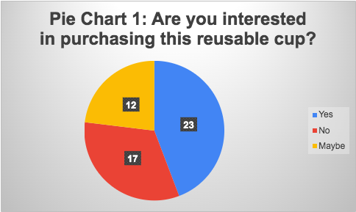

At PCUP we believe in the environmental importance of reducing our footprint and preserving natural resources. That is why we make all our reusable cups made from silicon, giving them a second life, generating top-quality products so that they last over time, and reducing our consumption needs.

# Situational Analysis:

A SWOT analysis is a study conducted to identify a company’s internal strengths and weaknesses and the company's external opportunities and threats. Below you can see the results of a SWOT analysis we created for PCUP.

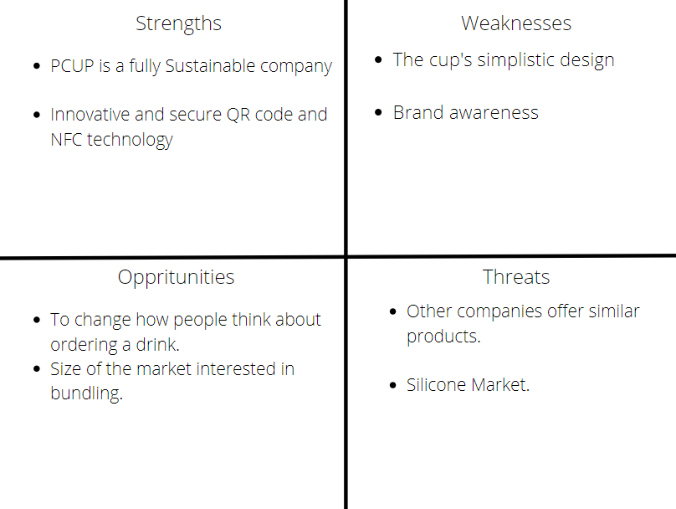

*Strengths:* PCUP’s product being fully sustainable leads to the company being seen as an ethical brand. Making marketing activities far more effective with the growing sustainably conscious population. PCUP also mitigates the risk of having to manage the QR code system by managing it themselves through their application. The technology within the cups paired with their application allows them to gather more information than ever before, tracking each and every single action of every single cup. The worry of constantly tracking the actions of accounts is removed through their proprietary encryption.

*Weaknesses:* PCUP’s product is not suited to being on the move. As a result of their product being this way, it can be difficult to motivate people to carry around a dirty cup, to then reuse and return it. Our survey has proven that college students are concerned with having the added mobility of the lid(Figure 2). Compared to other companies in the same industry, one of the things that PCUP is lacking would be brand awareness. The awareness to be able to trust in a brand to be reliable.

*Opportunities:* The opportunity to take the attention of the consumer away from the cup and to focus on purchasing the actual liquid. PCUP’s system being a sharing system leads to the focus of the consumer to be brought back to the liquid. The information gained by the cups' technology (<https://www.pcup.info/>) can be the reason to carry the cup at all. Being able to make the purchase on the application allows PCUP to monitor the behaviors of consumers. Eventually, a system like this could be what keeps track of global beverages or even social trends.

*Threats*: There are many threats to this company when entering the United States, one of the leading threats to a company like this opening in the US would be competitors. Competing companies that take action and develop a similar system to PCUP’s system will likely already have customers and locations. For an example of companies using similar systems, Starbucks is using a system where they give both store credits and a rewards points system(Morgan Cook,2021). Due to the lack of supply in the silicone market because of growing countries and technologies, PCUP could see the price of silicone rise due to lack of supply.

# Marketing Strategy:

The marketing strategy will be based on the quantitative and qualitative surveys carried out in the USA. The data from the research survey will be used to create a marketing strategy for PCUP.

It is introductory human psychology to be attracted to lower prices in their quest to purchase products and services. From the data we collected in the survey, people said they were more inclined to buy the PCUP if we bundled a sleeve. By giving this option to the customers. We provide the customers with more ways to use the PCUP. Because if we add a sleeve with the PCUP, more people will want to use it at coffee shops more, and it would attract more customers. The success of PCUP depends on the rate to draw the first users who will influence others to use their products. On the other hand, giving discounts to people who use PCUP will attract more other users.

# Purchasing products and services at promotional and discount prices have been an essential marketing strategy that has attracted more customers. Implementing a discount prices strategy attracts many new customers to products and services compared to other methods (Kim et al., 2019). According to the data collected from Lorenzo's research survey, more people were willing to use the cups to get drinks and beverages at discounted prices. By using the discount marketing strategy, we anticipate attracting more than 30% of prospective customers and turning them into customers willing to walk around with cups to get discounts on drinks and beverages. The PCUP can be used anywhere, like parties, coffee shops, bars, clubs, homes, etc.… PCUP has a target population that consists of many college students arranged between the ages of 18 to 24.

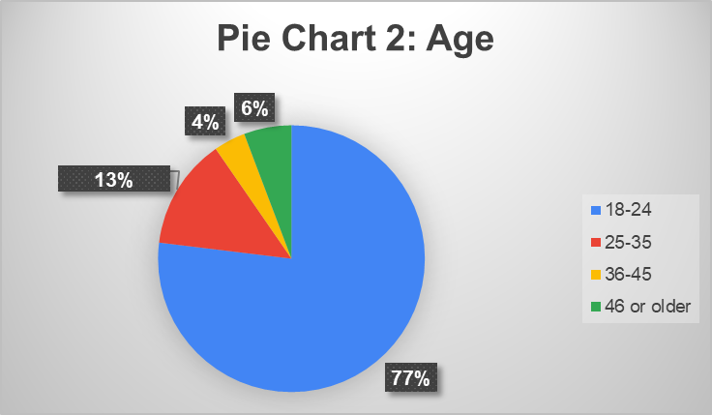

The targeted market meets in social places such as parties and coffee shops. The data collected from the research survey was analyzed and used to predict the behavior of the target population. Plus, the data suggested that the participants from the research survey were willing to use the reusable cups in coffee shops and parties. The PCUP is more likely to be used in clubs if users can save time by skipping lines to get drinks just by possessing the PCUP.

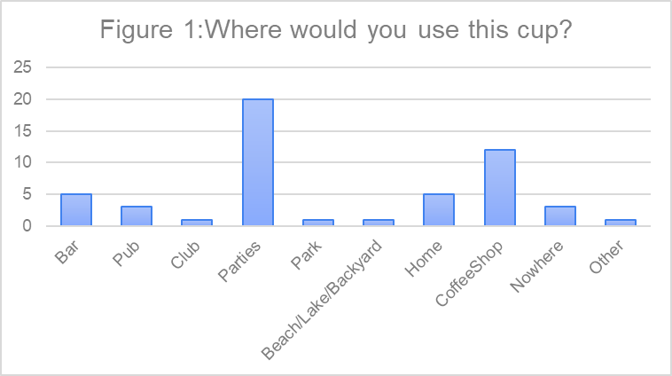

It is normal human behavior to get their services and products instantly without wasting a lot of time waiting to be served. From the data collected in the survey study, more participants were party-goers, but they hate standing in line outside clubs and waiting for their turn to enter. Giving parties goers the advantage of skipping lines in clubs because they possess the PCUP would be a great strategy to implement. The system will attract more party-goers to buy and keep reusable cups. The estimated number of reusable cups in clubs and parties would increase by more than 40%. This can also be achieved in coffee shops if the customers who possess the PCUP receive services faster than customers who do not.

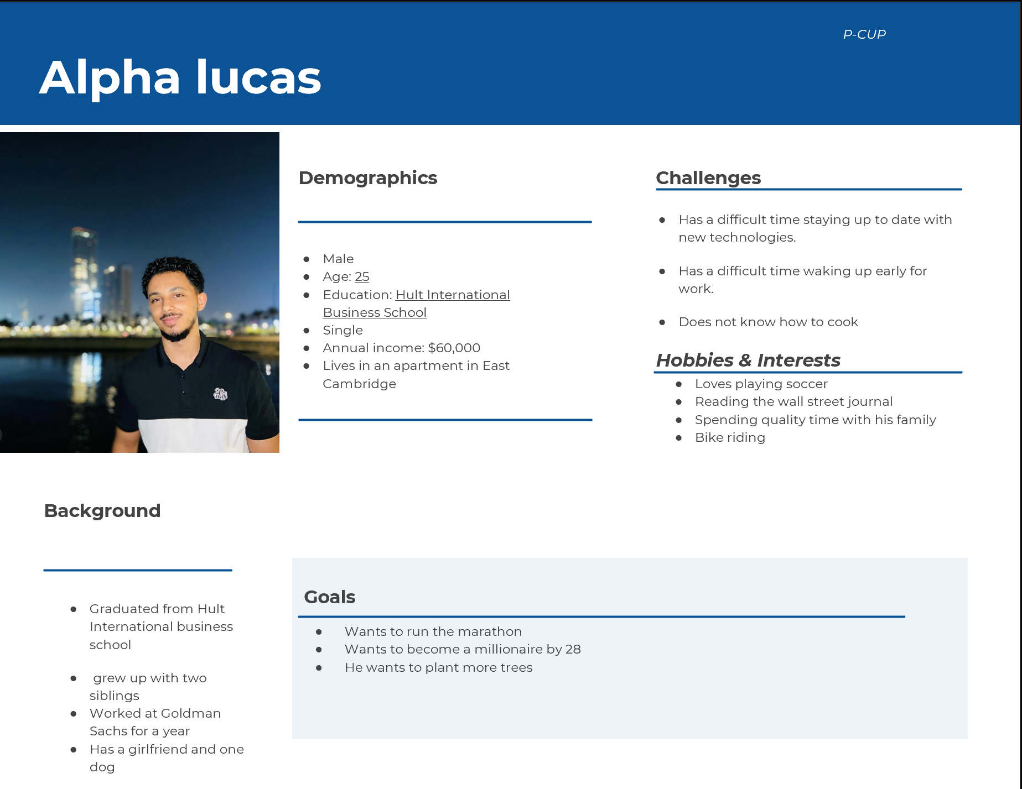

# Pricing strategy

There are several practical pricing strategies that PCUP can analyze and implement. In the survey, our team offered four types of price ranges ($3-$5, $5-$8, $8-$11, $11-$15) and preferable price options by customers. This approach helped to analyze what type of price range can work effectively for PCUP in the U.S. Accordingly, figure 6-“Price range” demonstrates that out of 52 respondents, 19 of them are willing to pay for the cup from $3 to $5 while another 19 respondents are willing to pay $5-$8. On the other hand, seven survey takers chose the price range $8-$11 whereas three of them chose $11-$15. Only two respondents prefer to pay nothing for a cup while 1 respondent is willing to pay $1 and one respondent is willing to pay $2.

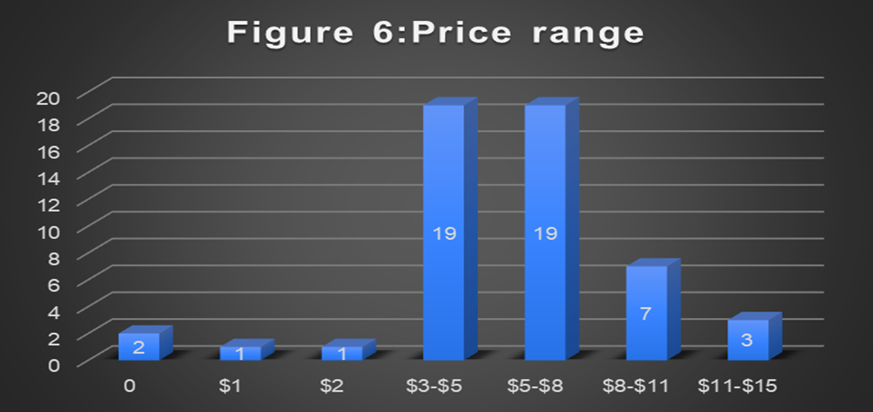

As most respondents selected the price range of $3-$5 and $5-$8, our team is convinced that a value-based pricing strategy can be effective for PCUP as it is based on pricing on how much the customer believes a product is worth ( Bloomenthal, 2020, para.1). The article “Value-Based Pricing-Definition, Advantages, Disadvantages” shows that it can increase profit when customers are willing to buy the product at any price, then the owner gets the chance to charge a high price for the product( Bhasin,2020, para. 20). However, the article also describes one of the main cons of value-based pricing- competition in the market. It specifically states that the company can give room for the competitors to produce and sell the same item at a lower price when you charge a higher price. As a result, the number of customers might diminish (Bhasin,2020, para. 25 &26).

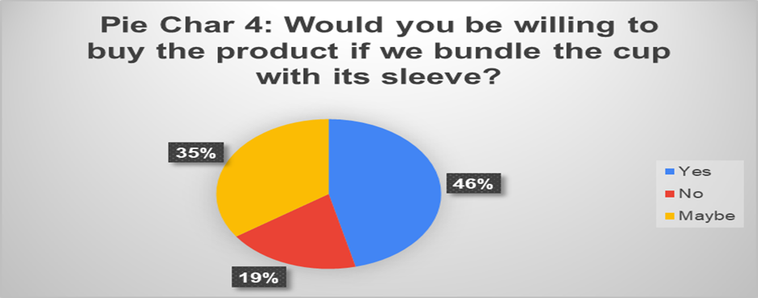

Also, our conducted survey proved that most customers are willing to buy the cup if we bundle it with its sleeve. To be specific, 46% of respondents answered “Yes” and 35% of them “Maybe” when we asked it in our survey. However, 19% of respondents are not willing to buy the product if we bundle the cup with its sleeve (Pie Chart 4).

These results show that bundling pricing strategies can be an effective approach for PCUP. Bundling pricing strategy defines a pricing strategy when the company or seller combines several products such as cup and sleeve and then sells them at a single price. There are several advantages of bundling price strategy. One of them is lower marketing and selling costs. The article “What are the advantages and disadvantages of bundle pricing” states that by bundling two or more products, the businesses like PCUP do not need to market single items in the inventory (Moran, 2020, para. 11). Additionally, in the short-term bundling, the product can eliminate more expenses such as promotional materials, shipping, affiliate, commission, total per-products cost, and so on (Moran, 2020, para. 12). Another advantage is the speed transaction process. The article claims that bundling will help business-customer relationships to speed up as they will not waste time on a single good or service (Moran, 2020, para. 18). However, PCUP still needs to be aware of risks regarding bundle pricing. One of the main risks that were mentioned in the article is barriers to entry which diminishes the possibility of a striking sale. Thich can happen when consumers may not want all the other items in the package and may reject the bundle and can go to another product option. Following that, 19% of respondents can be considered as one of these consumers. Referring to our findings and results from the survey, our team recommends PCUP should implement a value-based pricing strategy and bundle pricing strategy.

# Promotion:

Digital marketing strategy is taking the place of traditional marketing strategy day by day. Following that, PCUP should promote the cup by using a digital marketing strategy. To be specific, our team recommends using social media marketing which is one of the channels of digital marketing. In support of this recommendation, our team decided to create an Instagram page [(www.instagram.com/invites/contact/?i=1xhypp1g3ujj0&utm_content=ndy6m8d](http://(www.instagram.com/invites/contact/?i=1xhypp1g3ujj0&utm_content=ndy6m8d)) and a short video: [Final Version of PCUP Advertisement - YouTube](https://www.youtube.com/watch?v=w2R1hUj5a04&feature=youtu.be) that can be uploaded on the company’s YouTube channel and other PCUP’s social media pages. The posts and video will introduce the features and function of cups. For example, for the video, we used 5 different beverages- Gatorade, Coke, Nantucket Nectars Juice, two different types of Jarritos. In the video, there are several descriptions of the cup was mentioned, like:

· Sustainable material silicone

· Capability of 300 washes

· Solution to the problem of disposable glasses

· Indestructible glasses

· Connection to circle app

At the end of the video, we called the watcher to join our circle app and purchase that will allow them a safe environment with PCUP. We used a similar concept to Instagram posts.

Additionally, the article “4 Benefits of advertising Instagram” supports our recommendation. For example, the author claims that ads on Instagram are less likely to annoy your targeted audience, also the engagement rate on Instagram is higher than the engagement rate on any other social media platform (Katai, 2021, para. 19&20). The author also states that there are more than 700 million users on Instagram and nowadays it is continuously growing (Katai, 2021, para. 17). All in all, for promotion, our team recommends PCUP digital marketing, specifically, social media marketing such as Instagram.

# Implementation:

Our findings helped us define three steps that PCUP can take throughout 6 months and 1 year.

***Step 1:*** *To develop the design of the cup*. Our team considered the design of the cup as simple and not attractive. Therefore, we asked the survey taker are they willing to buy if we add a movable handle and lid to the cup (Figure 4). It showed that 15 respondents answered “Yes”, 22 respondents answered “Maybe”, and 15 respondents answered “No” regarding adding a movable handle to the cup. However, 31 respondents supported the idea of adding a lid, and 15 of them partially support this idea. But only 6 survey takers disagree with our recommendation toward adding the lid to the cup.

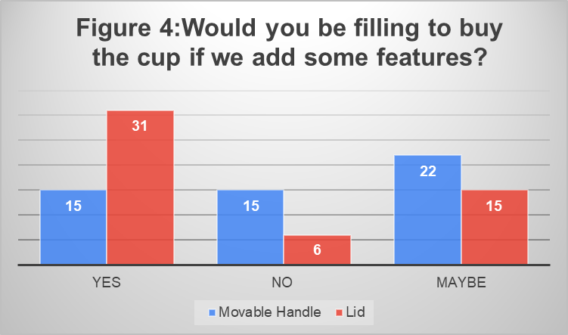

Furthermore, we asked respondents if they are given the option to customize or build their own designed cup by color, name, logo, adding company’s contact information, own motivational words, event names, and pictures. Figure 5 shows how many respondents support, slightly support, or do not support these recommendations by each separated feature.

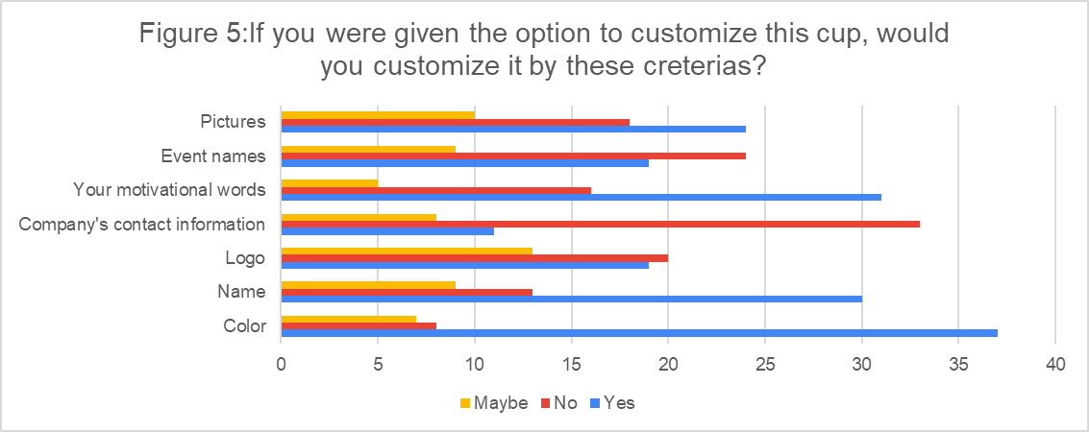

As customization will increase product cost, in the survey we asked how much they are willing to pay additionally for it. It demonstrated that 62% of respondents are willing to pay from $1 to$3 while 19% of them willing to pay from $3-$5. The remaining 19% of survey takers are not willing to pay an additional fee for the customization (PieChart 5).

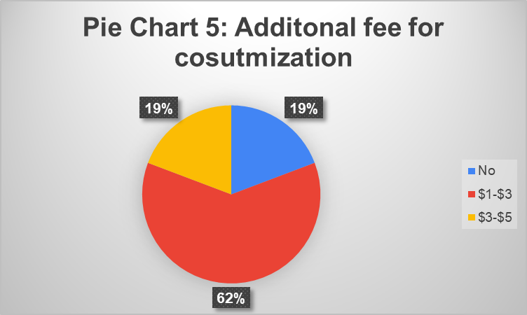

Overall, for 6 months or 1-year PCUP needs to work on the development of cup design and these findings can help make decisions.

***Step2:*** *Finding a place at the U.S. widespread retail stores*. With the product fully developed with multiple customization options, it's time to begin looking towards entering the market. With so many widespread retail stores already established in the U.S. moving into the market is only a choice of selection. With our target market being college students, the number of stores that they cover is vast. In more urban environments that colleges tend to be in stores like CVS and Target are taken for granted there are so many of them. By partnering with those companies the distribution of the product becomes simple through using their inbuilt systems.

Marketing the application that pairs with the cup will be vital for the customers to get the full value of the product. With pricing being variable based on what bundle or customization options they have; many stores will have the option to use the cups in their stores to be able to possibly integrate them into their stores.

***Step 3:*** *Keep updating the Instagram page regularly*. Nowadays social networks are an important part of everyone's life and not only for personal use but also to promote products or companies, over the years social networks become more and more revolutionary in the way in which a company evolves since here there are no border limits, without the need to expand physically, people from different cities or countries can even know or order your products from anywhere, it is very important to keep social networks up to date, that is why our plan is to always be present on our Instagram page, make daily posts and publish quality content, this is very important since we would make ourselves known to our mainly potential clients who are Hult students which are always active in social networks, parties are also promoted through here and it is a way of being able to enter with our products promoting them in a unique way.

***Recommendation and Conclusion***

In conclusion, we realize that PCUP is a company that is not only focused on creatingreusable products that benefit and help the environment, but we are also willing to revolutionize and change the beverage industry, using technologies that little by little we will be implementing and improving, as we mentioned, we bring a marketing and price strategy that will help us grow and improve our products and thus be able to reach the lives of more people, the plan is based on a survey that helped us to realize in which our possible clients prefer and from there we developed an adequate plan to be able to implement our project in the best possible way. Without a doubt, the implementations that we would take thanks to what we saw that helped us best, are things that will help us to be better known to people and also to be better as a company.

# Additional figures and pie chart from the survey result

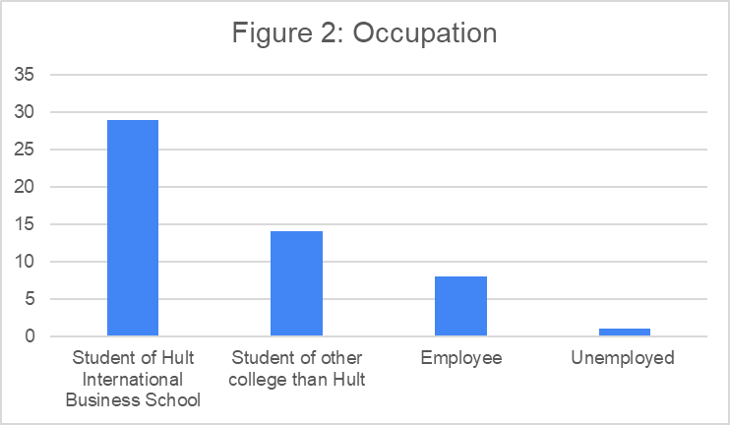

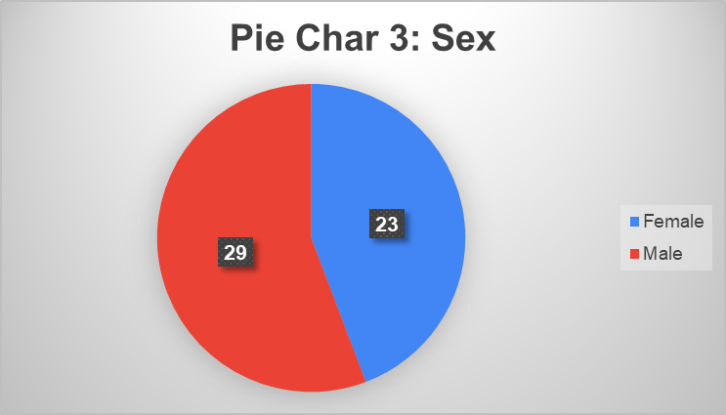

# 

# References:

Bhasin, H. (2020, February 15). *Value based pricing - definition, advantages, disadvantages*. Marketing91. Retrieved December 10, 2021, from <https://www.marketing91.com/value-based-pricing/>.

Bloomenthal, A. (2021, December 7). *Valuing value-based pricing*. Investopedia. Retrieved December 10, 2021, from <https://www.investopedia.com/terms/v/valuebasedpricing.asp>.

*Disposable cups market size: Industry report, 2021-2028*. Disposable Cups Market Size | Industry Report, 2021-2028. (n.d.). Retrieved December 10, 2021, from <https://www.grandviewresearch.com/industry-analysis/disposable-cups-market>.

*How starbucks' borrow a cup program works (and gets you free coffee!)*. Brightly. (2021, August 20). Retrieved December 10, 2021, from <https://brightly.eco/starbucks-borrow-a-cup-program/>.

Katai, R. (2021, November 12). *4 benefits to advertising on Instagram*. Social Media & Influencer Marketing Speaker, Consultant & Author. Retrieved December 10, 2021, from <https://nealschaffer.com/4-benefits-advertising-instagram/>.

Moran, A. (2020, August 26). *The advantages and disadvantages of bundle pricing: SB*. The Advantages and Disadvantages of Bundle Pricing | SB. Retrieved December 10, 2021, from <https://www.startingbusiness.com/blog/bundle-pricing>.

NewAdmin. (n.d.). *Zero Beverage Container Waste?* Deposit/Return Systems. Retrieved December 10, 2021, from <https://www.container-recycling.org/index.php/zero-beverage-container-waste/62-issues/zero-waste/338-depositreturn-systems->.